RESOLUTION NO.__________

RE: CERTIFICATE OF APPROPRIATENESS UNDER THE
PROVISIONS OF THE ACT OF THE PENNSYLVANIA
LEGISLATURE 1961, JUNE 13, P.L. 282 (53
SECTION 8004) AND BETHLEHEM ORDINANCE NO.
3952 AS AMENDED.

WHEREAS, it is proposed to install a new sign on the exterior of the building and vinyl door lettering at 220 E. Third Street.

NOW, THEREFORE, BE IT RESOLVED by the Council of the City of Bethlehem that a Certificate of Appropriateness is hereby granted for the work.

Sponsored by: (s)

(s)

ADOPTED BY COUNCIL THIS DAY OF

(s)
President of Council

ATTEST:

(s)
City Clerk

HISTORIC CONSERVATION COMMISSION

CASE # 531 – It is proposed to install a new sign on the exterior of the building and vinyl door lettering at 220 E. Third Street
OWNER/APPLICANT: Bethlehem Realty LLC / Ethan Lee

The Commission upon motion by Mr. Cornish seconded by Mr. Lader adopted the proposal that City Council issue a Certificate of Appropriateness for the proposed work described herein:
- The proposal to install a new sign on the exterior of the building and vinyl door lettering at 220 E. Third Street was presented by Kevin Luna.
- The sign will read “cricket” in black letters with part of the K to be green. The total size of the sign will be reduced approximately 20% to 24” high.
- The new sign will be aligned, as closely as possible, with the existing sign on the side of the building.
- The new sign will be halo illuminated.
- The thickness of the letters will be 3” and the letters will be mounted 2” off the façade.
- The new door sign will be white vinyl and read “cricket authorized retailer” with the hours, web address and social media buttons. The size of the sign will be as shown in the drawings submitted to the HCC.
- The proposed motion was unanimously approved.

CU: cu
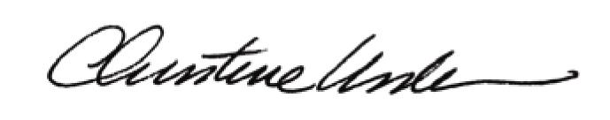

By:

Date of Meeting: February 18, 2015 Title: Historic Officer

